Australian Capital Territory Remuneration Tribunal

Determination 1 of 2023

Full-time Statutory Office Holder –
Aboriginal and Torres Strait Islander Children and Young People Commissioner
made under the
Remuneration Tribunal Act 1995, section 10 (Inquiries about holders of certain positions)

ACCOMPANYING STATEMENT

Background
Section 10 of the Remuneration Tribunal Act 1995 (the Act) provides for the Remuneration Tribunal (the Tribunal) to inquire into and determine the remuneration, allowances and other entitlements to be paid to a person holding a position or appointment mentioned in schedule 1 of the Act, or specified in an instrument given to the Tribunal by the Chief Minister.
On 14 December 2022, the Chief Minister requested the Tribunal to determine the remuneration, allowances and other entitlements for the Aboriginal and Torres Strait Islander Children and Young People Commissioner.

Considerations
The Tribunal noted that the Aboriginal and Torres Strait Islander Children and Young People Commissioner is a statutory office established to promote and protect the rights of Aboriginal and Torres Strait Islander children and young people. The Commissioner will be a full-time statutory office holder.
In considering the remuneration of the Commissioner, the Tribunal had regard to the proposed work value of the Aboriginal and Torres Strait Islander Children and Young People Commissioner, the remuneration of similar commissioners in the Territory as well as remuneration of similar positions in other jurisdictions. The Tribunal met with an official from the Justice and Community Safety Directorate.

Decision
The Tribunal determined remuneration of $238,765 per annum for the Aboriginal and Torres Strait Islander Children and Young People Commissioner.

25 January 2023
Australian Capital Territory Remuneration Tribunal

Full-time Statutory Office Holder –
Aboriginal and Torres Strait Islander Children and Young People Commissioner

Determination 1 of 2023
made under the
Remuneration Tribunal Act 1995, section 10 (Inquiries about holders of certain positions)

Commencement
This instrument commences on date of signature.

Remuneration

The remuneration for the Aboriginal and Torres Strait Islander Children and Young People Commissioner is $238,765 per annum.

3. Other Conditions
3.1 All conditions specified in Determination 4 of 2022 relating to Full-time Statutory Office Holders, or its replacement, will also apply to the Aboriginal and Torres Strait Islander Children and Young People Commissioner.

Ms Sandra Lambert AM  Chair | 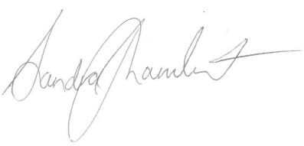  ................................................
Mr Dale Boucher PSM  Member | 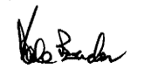  ...............................................
25 January 2023

