Australian Capital Territory Remuneration Tribunal

Determination 2 of 2023

Part-time Public Office Holder –
Chair, Official Visitors Board
made under the
Remuneration Tribunal Act 1995, section 10 (Inquiries about holders of certain positions)

ACCOMPANYING STATEMENT

Background
Section 10 of the Remuneration Tribunal Act 1995 (the Act) provides for the Remuneration Tribunal (the Tribunal) to inquire into and determine the remuneration, allowances and other entitlements to be paid to a person holding a position or appointment mentioned in schedule 1 of the Act, or specified in an instrument given to the Tribunal by the Chief Minister.
On 14 December 2022, the Chief Minister requested the Tribunal to determine the remuneration, allowances and other entitlements for the Chair of the Official Visitors Board.

Considerations
The Tribunal noted that the Official Visitors Board is a statutory body established to oversee, manage and support the exercise of functions by official visitors under the Official Visitors Act 2012. The Chair will be a part-time public office holder.
In considering the remuneration of the Chair, the Tribunal had regard to the proposed work value of the Chair of the Official Visitors Board as well as remuneration of similar positions in comparable jurisdictions. The Tribunal met with an official from the Justice and Community Safety Directorate.

Decision
The Tribunal determined remuneration of $26,390 per annum for the Chair of the Official Visitors Board.

25 January 2023
Australian Capital Territory Remuneration Tribunal

Part-time Public Office Holder –
Chair, Official Visitors Board

Determination 2 of 2023
made under the
Remuneration Tribunal Act 1995, section 10 (Inquiries about holders of certain positions)

Commencement
This instrument commences on date of signature.

Remuneration

The remuneration for the Chair of the Official Visitors Board is $26,390 per annum.

3. Other Conditions
3.1 All conditions specified in Determination 13 of 2022 relating to Part-time Public Office Holders, or its replacement, will also apply to the Chair of the Official Visitors Board.

Ms Sandra Lambert AM  Chair | 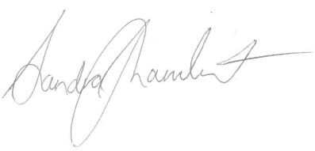  ................................................
Mr Dale Boucher PSM  Member | 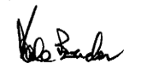  ...............................................
25 January 2023

