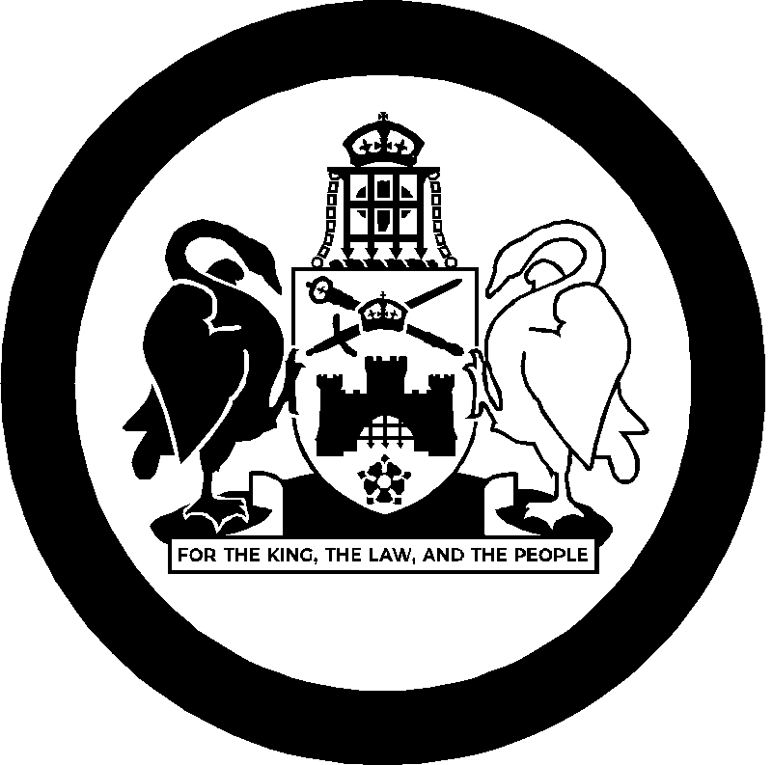
Australian Capital Territory Remuneration Tribunal

Determination 5 of 2026

Part-time Public Officeholder –
Co-Chairs and Members, ACT Reconciliation Council

made under the
Remuneration Tribunal Act 1995, section 10 (Inquiries about holders of certain positions)

ACCOMPANYING STATEMENT

Background
Section 10 of the Remuneration Tribunal Act 1995 (the Act) provides for the Remuneration Tribunal (the Tribunal) to inquire into and determine the remuneration, allowances and other entitlements to be paid to a person holding a position or appointment mentioned in schedule 1 of the Act, or specified in an instrument given to the Tribunal by the Chief Minister.
On 2 March 2026, the Chief Minister requested the Tribunal to determine the remuneration, allowances and other entitlements for the Chair and Members of the ACT Reconciliation Council.

Considerations

During the recent Autumn sitting, the ACT Reconciliation Council sought remuneration for all members of the Council and an additional payment for Aboriginal and Torres Strait Islander members of the council.

The Tribunal agreed that all members of the ACT Reconciliation Council are to be remunerated in a manner consistent with similar advisory bodies.

Further, the Tribunal acknowledges that Aboriginal and Torres Strait Islander members of the ACT Reconciliation Council experience particular personal accountabilities and additional leadership responsibilities, including nationally. As a result of this and their connection to community, together with the unique role of this Council, the Tribunal has decided that Aboriginal and Torres Strait Islander members of the Council will receive an additional payment.

The ACT Remuneration Tribunal considers this decision reflective of the unique role and circumstances of these members of the ACT Reconciliation Council.

Decision
ACT Reconciliation Council
The Tribunal determines that the co-chairs will be remunerated at $650, and Members at $560 in line with other Ministerial Advisory Councils.
The Tribunal acknowledges that Aboriginal and Torres Strait Islander members of the ACT Reconciliation Council experience particular personal accountabilities and additional leadership responsibilities, including nationally. As a result of this and their connection to community, together with the specific role of this Council, the Tribunal has decided that Aboriginal and Torres Strait Islander members of the Council are to receive an additional 20 per cent of the daily rate (per diem) in recognition of this cultural load.

14 April 2026
Australian Capital Territory Remuneration Tribunal

Determination 5 of 2026

Part-time Public Officeholder –
Co-Chairs and Members, ACT Reconciliation Council

made under the
Remuneration Tribunal Act 1995, section 10 (Inquiries about holders of certain positions)

Commencement
  - This instrument is taken to have commenced on the date of signature.

Remuneration

The remuneration for the Co-Chairs of the ACT Reconciliation Council is $650 per diem.

The remuneration for Members of the ACT Reconciliation Council is $560 per diem.

Aboriginal and Torres Strait Islander members of the Council are to receive an additional 20 per cent of the daily rate (per diem) in recognition of this cultural load.

3. Other Conditions
3.1 All conditions specified in Determination 13 of 2025 relating to Part-time Public Officeholders, or its replacement, will also apply to the Chair and Members of the ACT Reconciliation Council and the CIT Academic Council.
Ms Sandra Lambert AM
Chair
Ms Pam Davoren PSM
Member

16 April 2026

